Pizza Sales SQL Queries

- KPI’s
1.Total Revenue:
SELECT SUM(total_price) as Total_Revenue
FROM pizza_sales
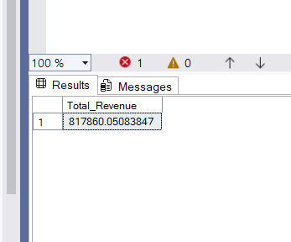

2.Average Order Value:
SELECT SUM(total_price)/Count(DISTINCT order_id) as Average_Order_Value
FROM pizza_sales
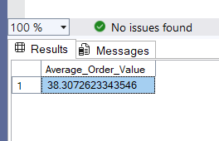

3. Total Pizzas Sold:
SELECT SUM(quantity) as Total_Pizzas_Sold FROM pizza_sales
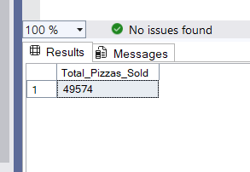

4. Total Orders:
SELECT COUNT(DISTINCT order_id) as Total_Orders
FROM pizza_sales
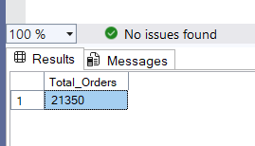

5. Average Pizzas Per Order:
SELECT CAST(Cast(Sum(quantity) AS DECIMAL(10,2)) /
CAST(Count(DISTINCT order_id) AS DECIMAL(10,2)) AS DECIMAL (10,2))
AS Average_Pizzas_Per_Order FROM pizza_sales
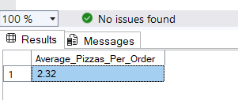

- Charts

- Daily Trend For Total Orders:
SELECT DATENAME(DW, order_date) as ordr_day,
COUNT(DISTINCT order_id) AS Total_Orders
FROM pizza_sales
GROUP BY DATENAME(DW, order_date)
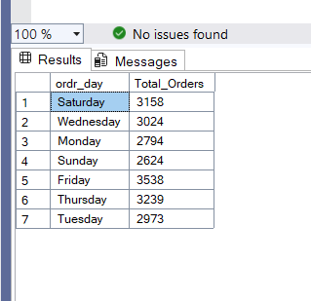

- Hourly Trend For Total Orders:
SELECT DATEPART(HOUR, order_time) as order_hour,
COUNT(DISTINCT order_id) AS Total_Orders
FROM pizza_sales
GROUP BY DATEPART(HOUR, order_time)
ORDER BY order_hour
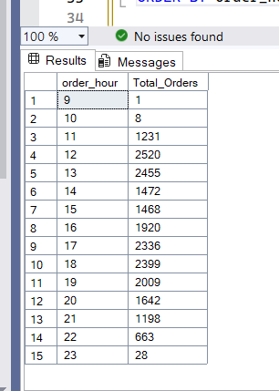
- Percentage Of Sales By Pizza Category:
SELECT pizza_category, CAST(sum(total_price) * 100 /
(SELECT SUM(total_price) from pizza_sales) AS DECIMAL(10,2)) AS Percentage_Of_Sales
From pizza_sales
GROUP BY pizza_category

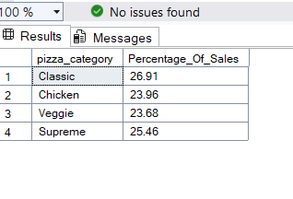

- Percentage Of Sales By Pizza Size:

SELECT pizza_size, CAST(sum(total_price) * 100 /
(SELECT SUM(total_price) from pizza_sales) AS DECIMAL(10,2)) AS Percentage_Of_Sales
from pizza_sales
GROUP BY pizza_size
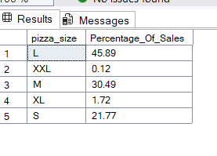

- Total Pizzas Sold By Pizza Category:
SELECT pizza_category, SUM(quantity) as Total_Pizzas_Sold
FROM pizza_sales
GROUP BY pizza_category
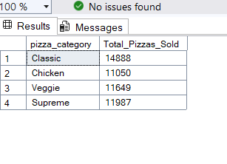

- Top 5 Best Sellers BY Total Pizzas Sold:
SELECT TOP 5 pizza_name, SUM(quantity) as Total_Pizzas_Sold
FROM pizza_sales
GROUP BY pizza_name
order by Total_Pizzas_Sold desc
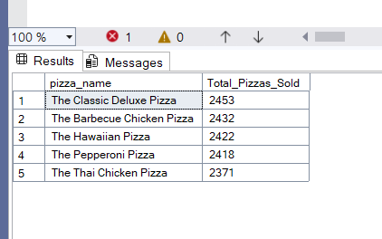

- Bottom 5 Worst Sellers BY Total Pizzas Sold:
SELECT TOP 5 pizza_name, SUM(quantity) as Total_Pizzas_Sold
FROM pizza_sales
GROUP BY pizza_name
order by Total_Pizzas_Sold asc
